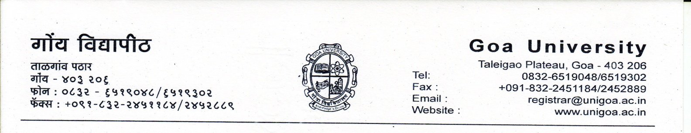
CONVOCATION FEES AS PER NOTIFICATION NO. GU/EXAM/FEE/20/2017/241/1342 DATED 28/07/2017

1. Professional Degrees : Rs.1260.00
2. Non Professional Degrees : Rs.735.00
3. Postal Charges in Absentia (within India) : Rs.160.00
4. Postal Charges in absentia (abroad) : Rs.1260.00
5. Search fee for Convocation degree
i) Upto 05 years : NIL
ii) Above 05 years : Rs.105.00 per year but not
exceeding Rs. 1050/-

